Analyzing the accelerating sales of used cars in a digitally disrupted market

To cater to digitally aware used-car consumers, dealers, investors, and innovators can step up their game.

Pranav Mekal Mahesh  
Computer Science & Engineering  
PES UniversityBangalore, India  
pranavmm25@gmail.com Mayuravarsha P  
Computer Science & Engineering  
PES UniversityBangalore, India  
mayurvp72@gmail.comVedant Mantri  
Computer Science & Engineering  
PES UniversityBangalore, India  
vedantmantri3@gmail.com

***Abstract*— Used-car selling is being disrupted by the internet revolution, and it's for the better. This new era of digital commerce is more than just about technology; it emphasises the importance of the consumer experience in the used-car purchase process.**

# Introduction

Online suppliers are beginning to erode traditional used-car dealers' standing and promote growth by empowering digitally savvy customers via three primary capabilities, as indicated by our unique customer research:

* complete end-to-end purchasing capabilities
* extensive vehicle data and photos, along with effective search tools
* unique delivery options

With the development of digital players and the possibility of incumbent-dealer consolidation on the horizon, the developing market will present new dangers and opportunities for firms looking to gain a competitive advantage in an already crowded sector.

Furthermore, while customer purchasing habits are evolving, it is true that the needs of used-car buyers differ significantly from those of new-car buyers. As a result, all used-car merchants must identify their target client categories and quickly design the best ways among a growing number of accessible options in order to provide a uniformly distinctive and distinguishing customer experience.

# craigslist

Craigslist is a classified ads website in the United States that has sections for employment, housing, for sale, desired items, services, community service, gigs, résumés, and discussion forums.

Craig Newmark started the service in 1995 as a friend-to-friend email distribution list for local events in the San Francisco Bay Area. In 1996, it transitioned to a web-based service and expanded into more classified areas. In the year 2000, it began growing to other U.S. and Canadian cities, and it presently serves 70 countries.

Spanish, French, Italian, German, and Portuguese were the first non-English languages to be supported by Craigslist in March 2008.

With more than 49.4 million unique monthly visitors in the United States alone, the site offers more than 20 billion[12] page views each month, putting it in 72nd rank overall among websites globally and 11th place overall among websites in the United States (per Alexa.com on June 28, 2016). (per Compete.com on January 8, 2010). Craigslist is the most popular classifieds service in the world, with over 80 million new classified ads added each month.

Every month, the site receives over 2 million new job listings, making it one of the most popular job boards in the world. As of October 2011, the 23 largest U.S. cities listed on Craigslist's home page received over 300,000 listings each day in the "for sale" and "housing" sections alone. Traditional buy/sell ads, community notices, and personal ads are all included in the classified ads.

Craigslist had a workforce of 28 workers in 2009.

# NEW PLAYERS

Carvana, Fair, and Vroom, among others, are among the new digitally savvy entrants aiming to disrupt the market. These businesses can leverage a variety of advanced digital skills, such as big data analytics and advanced digital platforms, to differentiate themselves from traditional used-car dealerships. At the same time, established new-car dealer groups and OEMs are working to maintain and increase this vital revenue stream.

The used-car inventory in the United States is getting younger and more expensive. There has been a significant movement in the market toward later-model vehicles. According to our analysis, the used-vehicle profile will grow substantially younger between 2017 and 2022, with major drop-offs in automobiles seven years and older as more consumers upgrade from older, less expensive vehicles.

# DATASET

The data contains most all relevant information that Craigslist provides on car sales including columns like price, condition, manufacturer, latitude/longitude, and 18 other categories.

Name of the dataset : vehicles.csv

This dataset consists of :

* 423867 rows
* 25 columns
* The image on the right shows us the percentage of missing values in each column.

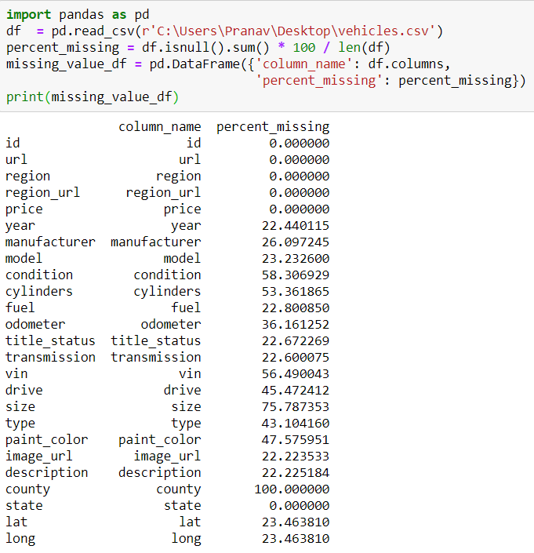

Graphs :

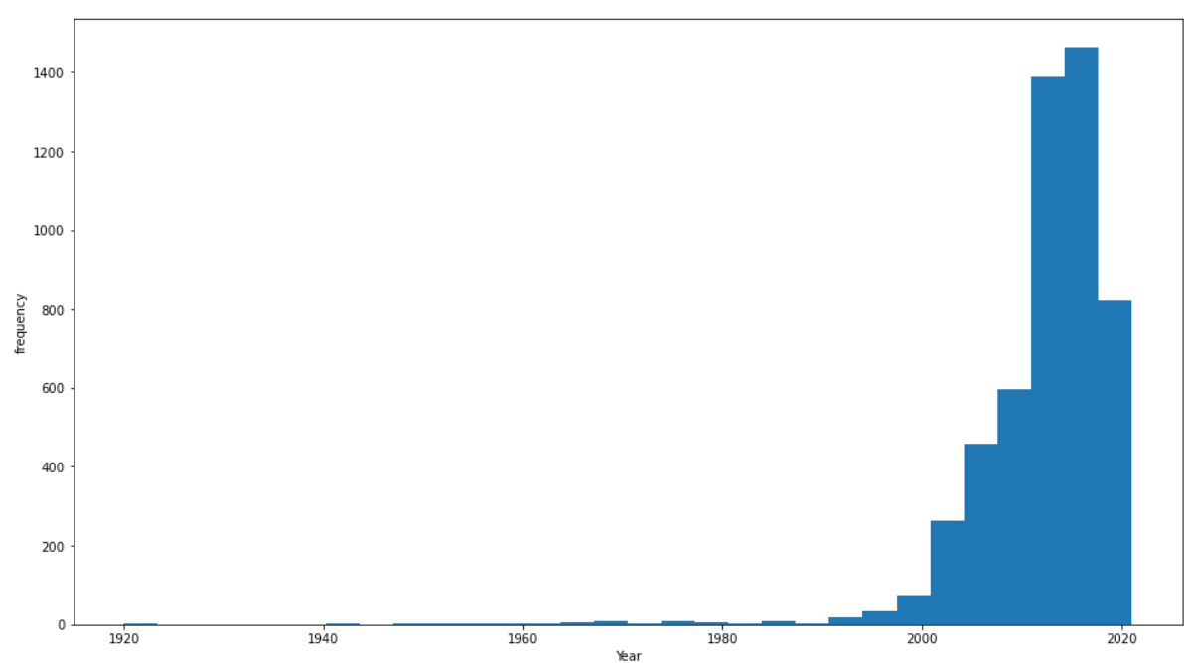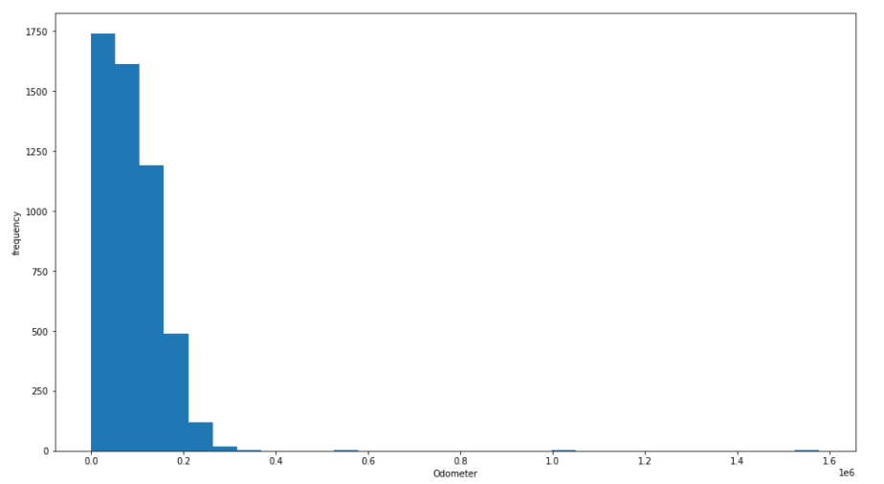

Normalization:

Normalization distribution graphs :

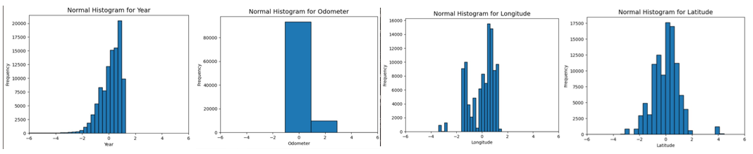

Hypothesis Testing:

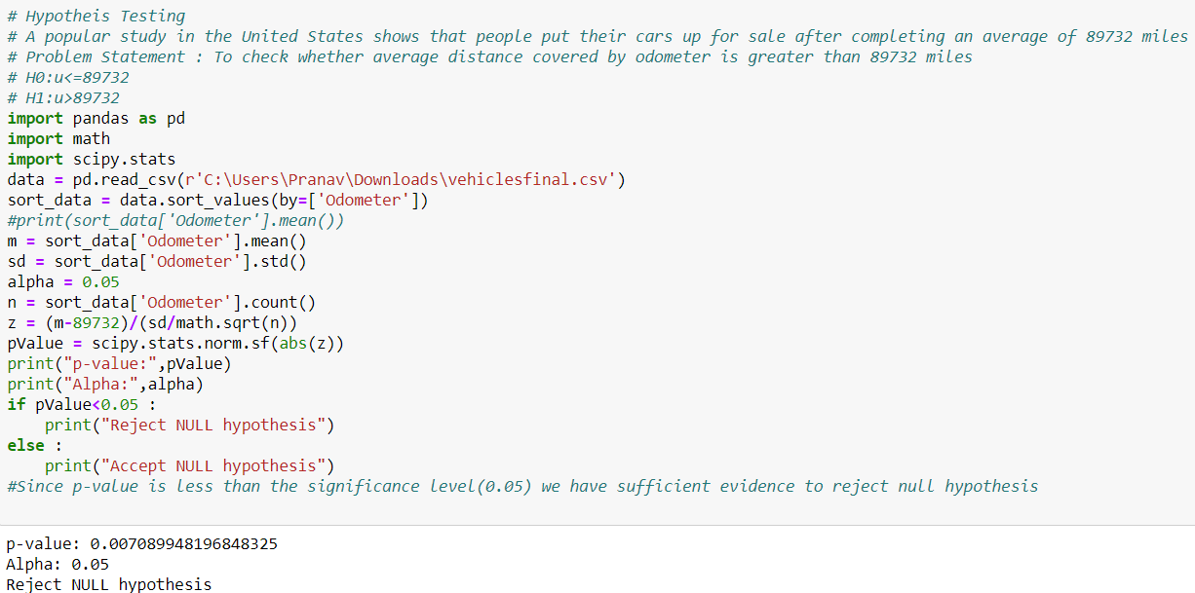

Correlation:

Here we can see that Price and Odometer are negatively related (more the distance covered, lesser the price). Similarly Odometer and year.

Year and Price are positively related (more newer the model, higher the price).

ID, Latitude and Longitude are ignored because they have no correlation.

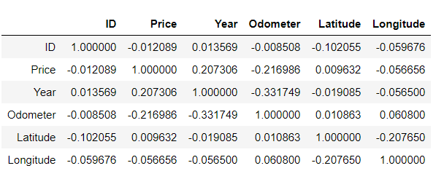

References :

https://www.mckinsey.com/~/media/McKinsey/Industries/Automotive%20and%20Assembly/Our%20Insights/Used%20cars%20new%20platforms%20Accelerating%20sales%20in%20a%20digitally%20disrupted%20market/Used-cars-new-platforms-Accelerating-sales-in-a-digitally-disrupted-market-vF.pdf